
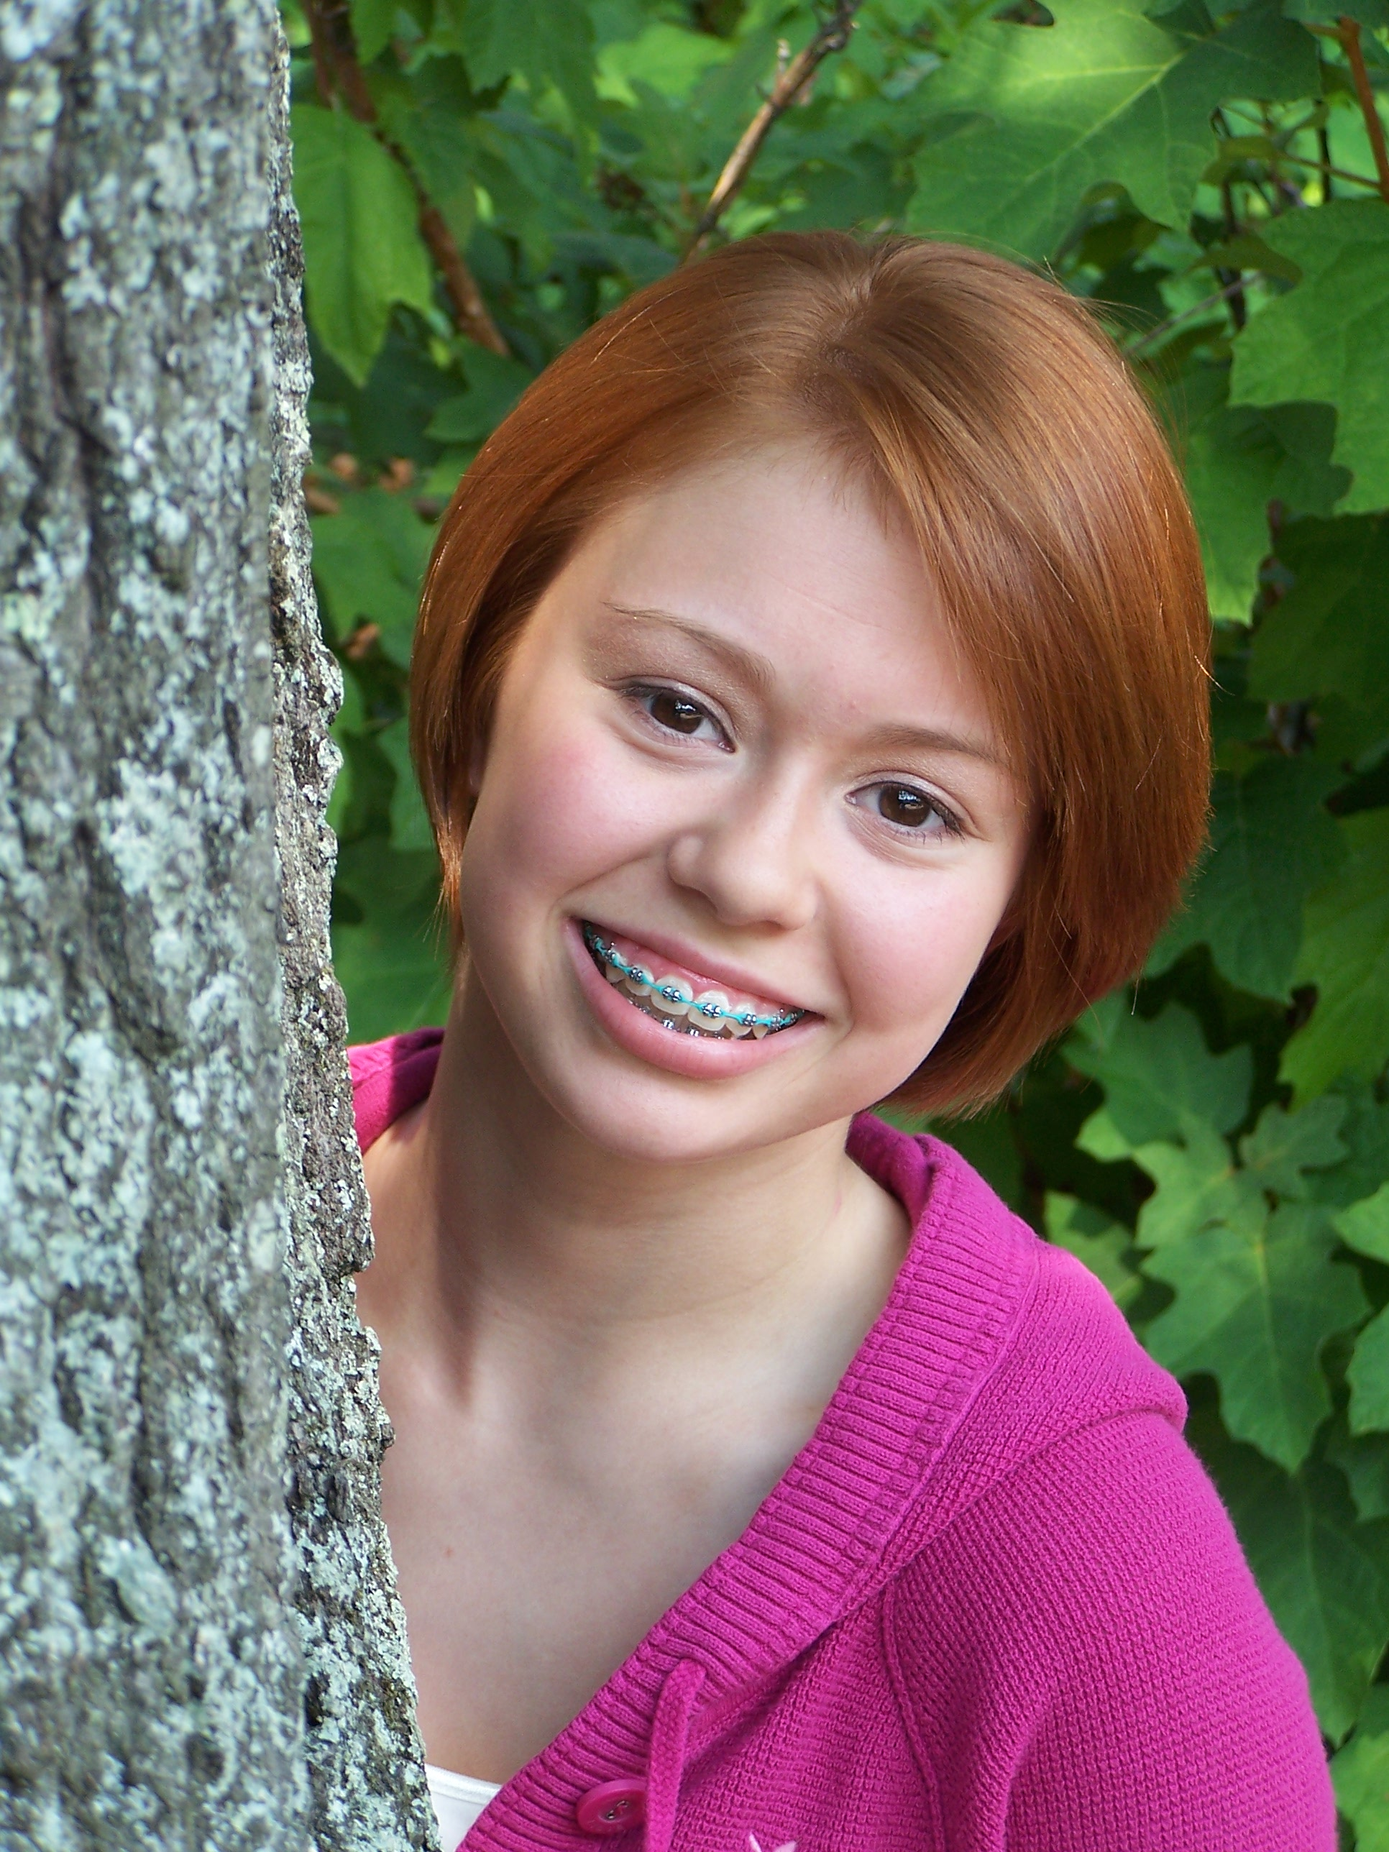
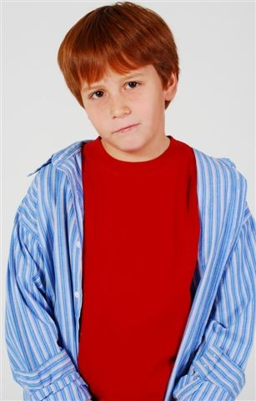
Beautiful Faces of Georgia
August 16th, 2008
Holiday Inn
2024 Watson Blvd, Warner Robins
Registration 12PM- 1PM, event begins at 1PM
Deadline to enter with check is August 4^{tth}, or enter with cash at the door

Proudly hosted by Warner Robins models Maria & Nik Lopez

About us

BFG is a natural modeling scout competition that celebrates NATURAL BEAUTY. Our judging panel consists of agents from the top modeling and talent agencies in the Southeast. Launched in August of 2004 we have helped over 350 contestants from all over GA to be discovered and signed. Many have already been cast in major print ad campaigns, catalogs, commercials, and feature films! These were regular kids just like your child that had a special spark and were seen and discovered by the right people. No classes or portfolios are needed or required. We use only reputable booking agencies that make money by finding your children work. We do not use or promote agencies that solicit for classes or portfolios.

All you need at BFG is a great face and a winning smile!

Age Divisions
Girls
0-2 yrs 3-5yrs 6-8yrs 9-12yrs 13+
Boys
0-2yrs 3-5yrs 6-8yrs 9-12yrs 13+

Awards
Age division winners will receive a beautiful Top Model trophy
All children competing will receive a trophy for competing! No one leaves empty handed.
There will be 2 overall winners selected one from 0-5 and one from 6-up. This will be the contestant with the highest scores in their overall age bracket of the competition.
They will receive a 4 ft trophy
We will compete and scout all children ages 0-5 years before beginning competition for 6- up.

Attire & Judging
Attire is blue jean bottoms, long jeans, shorts, or skirts, as long as they are blue jean material and a white shirt of any style. Shirt may have trim, but all trim must be white. All contestants are judged on first impression, natural beauty, and personality. THIS IS A NATURAL COMPETITION. No make up for girls ages 12 and under, age appropriate make up only for 13 and up. Hair should be a natural style and not over done, hair bows and barrettes are allowed (no heavy hair spray). Our judging panels consist of agents scouting for new talent to represent. All contestants will be judged standing directly in front of the judging table for up close appraisal and interview or interaction, there is no stage. You will know the day of the event if you have been scouted! Score sheets will be given and you will be allowed to speak with the agents in attendance.

$ Overall Most Beautiful/Handsome Jackpot $
This is an optional event and does not affect the overall awards or age division awards. It is based only on the contestant’s natural beauty scores and there will be 2 winners, one in 0-5, one in 6-up. The inners will receive half of all the money taken in for this optional in the contestant’s overall age bracket.

Door Admission
One adult enters free with contestant- all others must have arm band to enter.
Adults- $5.00 each, children 5-up $3.00 each, children under 4 enter free

Entry Form (Please Print)

Please submit picture with entry form with name, age, clothes size, and phone number on back. Natural snapshots are preferred. Photos are not scored and are not returned, we keep these on file for calls & castings.
You may enter the week of the event but only online with Visa, Mastercard, or Paypal, or pay with cash at the door.

Entry fee (includes overall) this fee is mandatory $75.00 _____
Overall most beautiful jackpot (judged solely on facial beauty scores) $10.00______
Winner will win ½ of all money taken in for this event in contestant’s age bracket, this is an optional
Entering everything above (beauty, overall & OMB jackpot) $85.00______
Sibling Discount name of sister/brother______________________ $50.00______
Sibling overall most beautiful jackpot $10.00_______
Only one sibling discount for every full entry fee paid, sibling discount does not apply to OMB jackpot
Location entering_________________________________________

Contestant’s Name____________________________________ Age______________ DOB____________________ M/F____
Address_______________________________________________
City______________________ Zip Code__________________
Phone#_______________________ Email____________________
Parent/s names__________________________________________
Eye Color_________________ Hair Color__________________
Hobbies_______________________________________________
Special Talents_________________________________________
Favorite Color__________________________________________
Favorite TV show or Actor/Actress__________________________
Ambition________________________________________________
________________________________________________________
How did you hear about BFG?______________________________

I hereby certify that Beautiful Faces of Georgia, staff, and facility where pageant or event is being held, or anyone associated with this pageant are not responsible for accidents, injury, or theft incurred before, during, or after the pageant and therefore release any liability to said parties. Judges decisions are final. Poor sportsmanship will result in disqualification of contestant and prizes (this includes contestant and family members). The director reserves the right to cancel event due to lack of participation; refund will only be given if rescheduled date is not within 60 days of original date scheduled. I understand no refund will be given if contestant fails to show or is disqualified because of misconduct by contestant or family member. I also understand that Beautiful Faces of Georgia and their associates make no promises of any contestant being signed and if they are we are not affiliated and will not be held responsible for actions or contracts on behalf of the agencies.

Parent Signature___________________________________________Date__________
Contestant Signature ( if 18 or over)_________________________________

Mail Entries with check or money order to:

Beautiful Faces of Georgia

PO Box 100, Orchard Hill, GA 30266
Questions please call Mrs. Monica Daniels: 770-412-6201 or visit www.beautifulfacesofga.com
Please make all checks and money orders out to: Beautiful faces of GA

